**Building A Restaurant Website With Bootstrap**

**Output:**

Homepage

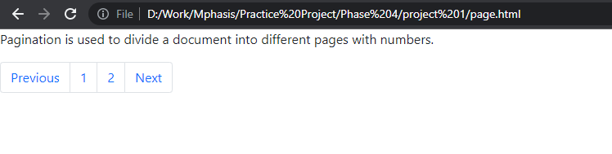

Restaurant website

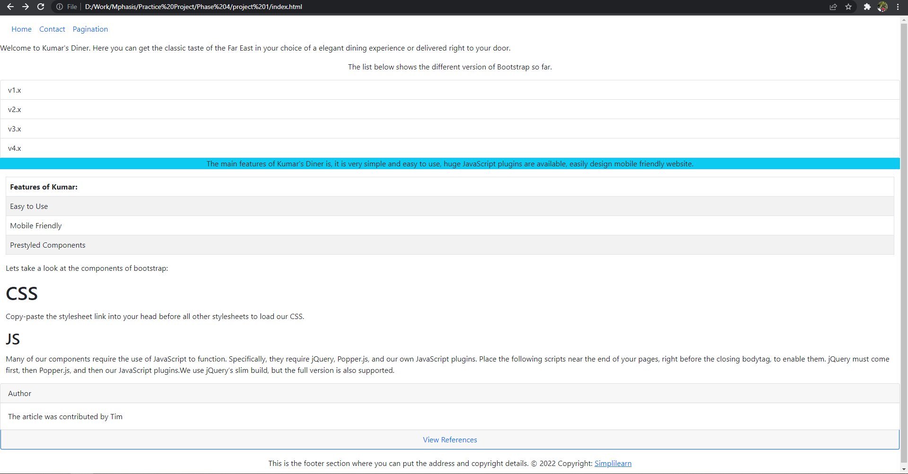

Contact form

